HTML & CSS Assignment

1.How are inline and block elements different from each other?
INLINE ELEMENT:
An inline element does not cause a line break (start on a new line) and does not take up the full width of a page, only the space bounded by its opening and closing tag. It is usually used within other HTML elements.
Other examples of inline elements are:
- anchor<a>tag
- emphasis<em>tag
- image<img>tag
eg)
<p>This is an inline span <span style="border: 1px solid black">Hello World</span> element inside a paragraph.</p>
Output:
This is an inline span Hello World element inside a paragraph.

BLOCK ELEMENT:
A block-level element always starts on a new line and takes up the full width of a page, from left to right. A block-level element can take up one line or multiple lines and has a line break before and after the element.
Other examples of the block-level tag are:
- Heading tags<h1>to<h6>
- List (Ordered, Unordered, Description and List Item) tags<ol>,<ul>,<dl>,<li>
- Pre-formatted text tag<pre>

eg)
<div style="border: 1px solid black">Hello World</div>
<p>The DIV element is a block element, and will always start on a new line and take up the full width available (stretches out to the left and right as far as it can).</p>
OUTPUT:

Hello World
The DIV element is a block element, and will always start on a new line and take up the full width available (stretches out to the left and right as far as it can).

2.Explain the difference between visibility:hidden and display:none.
The CSS rules visibility:hidden and display:none both result in the element not being visible.
Display : hidden means the tag will not appear at all on the page whereas visibility:hidden allocates the space on the page and just dont allow us to see it through the page

3. Explain the clear and float properties.
Float:
The float property is used for positioning and formatting content e.g. let an image float left to the text in a container.
The float property can have one of the following values:
- left - The element floats to the left of its container
- right - The element floats to the right of its container
- none - The element does not float (will be displayed just where it occurs in the text). This is default.
In its simplest use, the float property can be used to wrap text around images.
eg)
img {
float: right;
}
<p><img src="pineapple.jpg" alt="Pineapple">Lorem ipsum dolor sit amet, consectetur adipiscing elit. Phasellus imperdiet, nulla et dictum interdum</p>

Clear:
The clear property is directly related to the float property. It specifies if an element should be next to the floated elements or if it should move below them. This property applies to both floated and non-floated elements.
If an element can fit in the horizontal space next to the floated elements,it will. Unless you apply the clear property to that element in the same direction as the float. Then the element will move below the floated elements.
Every element created in CSS needs to have the quality design added.
The clear property can have following values:
- None- the element is not moved down to clear past floats.
- Left- the element is moved down to clear past left floats.
- Right - the element is moved down to clear past right floats.
- Both- the element is moved down to clear past both left and right floats.
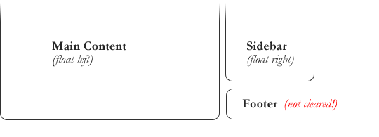
eg)

After applying clear:
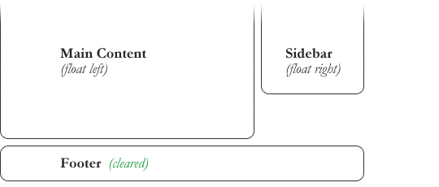

4. explain difference between absolute, relative,fixed and static.
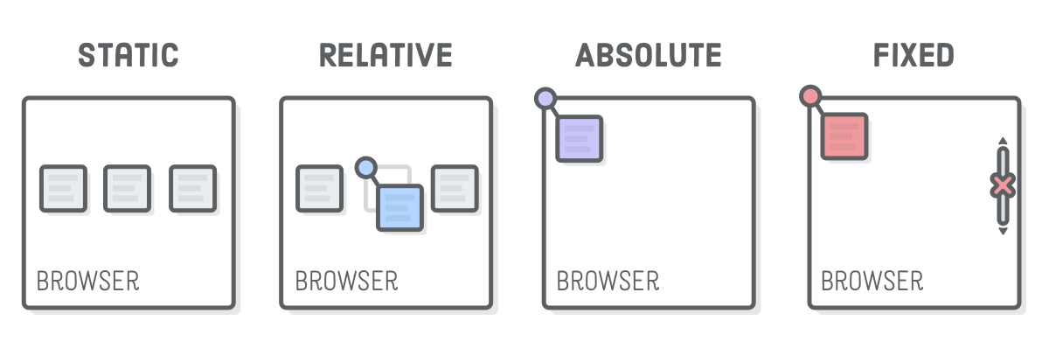

Fixed:
An element with position: fixed; is position relative to the viewport, which means it stays at the same place even if the page is scrolled.
The properties used to position element are top, right, bottom and left.
Static:
An element with position: static; is not positioned in a special away but it is positioned according to the flow of the page:
They are not affected by properties like top, bottom, left, and right.
HTML elements are positioned static by default.

Absolute:
An element with position: absolute; is positioned relative to the nearest positioned ancestor(instead of position relative to the viewport, like fixed)
However, if an absolute positioned element has no positioned ancestor, it uses the document body and moves along with page scrolling.

Relative:
An element with position: relative; is positioned relative to its normal position.
Setting the top, right, bottom, and left properties of the relative-positioned element will cause it to be adjusted away from its normal position.

5. Write the HTML code to create a table in which there are 4 columns( ID , Employee Name, Designation, Department) and at least 6 rows. Also do some styling to it.
Ques 5 uploaded in Git Repository
filename- Ques 5.html
6. Why do we use meta tags?
Metadata is data about data. It is information that describes some other information in a meaninful way. The meta tag is used in an HTML document to provide high level metadata about the web page: information that describes the web page in a meaningful way that can be understood by web browsers.
What sort of metadata can we provide to web browsers with the meta tag?
- A page description and the keywords that describe the subject of the page.
- Page authorship information.
- Instructions for specific browser actions.
- Details about the page title, description, and author to be used when the page is posted on social media or shown in SERPs.

eg - Define keywords for search engines:
<meta name="keywords" content="HTML, CSS, XML, XHTML, JavaScript">

7. Explain box model.
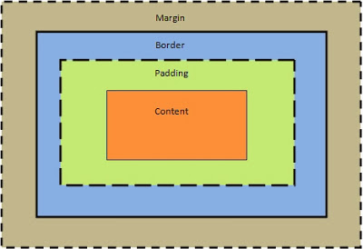
All HTML elements can be considered as boxes. In CSS, the term "box model" is used when talking about design and layout.
The CSS box model is essentially a box that wraps around every HTML element. It consists of: margins, borders, padding, and the actual content. The image below illustrates the box model:
Explanation of the different parts:
- Content - The content of the box, where text and images appear
- Padding - Clears an area around the content. The padding is transparent
- Border - A border that goes around the padding and content
- Margin - Clears an area outside the border. The margin is transparent
The box model allows us to add a border around elements, and to define space between elements.

8. What are the different types of CSS Selectors?
1. Universal Selector
Selects all child elements under the parent element. Here style is applied to every element under the parent element. Its weight is more and to be used with care.

2. Class Selector
Selects specified CSS class applied elements on the page. CSS class selector name starts with “.” followed by name.

3. ID Selector
Selects element which has a specified ID name. CSS ID selector name starts with “#” followed by name.
ID name to be unique in a web page.

4. Element Selector
Selects elements based on element type.

5) CSS Group Selector
The grouping selector is used to select all the elements with the same style definitions.
Grouping selector is used to minimize the code. Commas are used to separate each selector in grouping.

9. Define Doctype.
A doctype or document type declaration is an instruction which tells the web browser about the markup language in which the current page is written. The Doctype is not an element or tag, it lets the browser know about the version of or standard of HTML or any other markup language that is being used in the document.
HTML5
<!DOCTYPE html>

HTML 4.01

<!DOCTYPE HTML PUBLIC "-//W3C//DTD HTML 4.01//EN" "http://www.w3.org/TR/html4/strict.dtd">

10. Explain 5 HTML5 semantic tags.
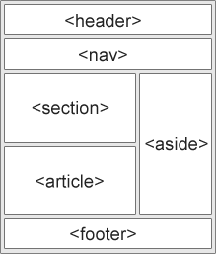
<section> Defines the section in an HTML document.
<nav> used to define the navigation bar with predefined settings.

<header> Defines the head section in the Document.

<article> element specifies independent, self-contained content.

<footer> element specifies a footer for a document or section.

Question NO. 11 and 12 are uploaded in the GIT repository.

11. Create HTML for web-page.jpg .
Files are – Ques11.html and Ques11css.css
12. Create HTML for form.png.
Files are- form.html and design_form.css

